**Mm. 150-520**

|  |  |  |  |
| --- | --- | --- | --- |
| 153 | Vla | Added ***f***, also added treble clef for mm. 153-54. | thanks |
| 162 | Cl | Added bass clef. | thanks |
| 166 4’ | Vla | Moved the treble clef one beat earlier. | thanks |
| 165-68 | Pno | Can you clarify what happens with the pedal here? | Pedal second half of m166, dry m167. Pedal gets back second half of 168 as written |
| 171 | Fl | What’s the text? | Tongue ram (note should be C#) |
| 175 | Perc I | Added tip -> grip | thanks |
| 175 | Vla, Vc | 8th rest at the end, or dotted quarter? | Eight rest, thanks |
| 178 | Cl | Should there be articulations on these notes? | Yes, thanks |
| 192 1’ | Vln I | Added arco | thanks |
| 196 | Vln I | Add quarter sharp above trill? | Add quarter sharp above trill, also note is wrong, should be C ¼ sharp |
| 210 | Sx | What does this symbol refer to? | Replace with accent + staccato |
| 217 | Ob | What’s the text above trill? | double trill |
| 220 4+ | Cb | Add Bartok pizz? | No |
| 223 2+ | Hn | What’s the text on the arrow? | “harm gliss”…maybe replace with “rip” |
| 238-39 | Sax | Are these the correct notes? | Yes, only Db should be tied to 240 |
| 240 | Ob, Sax | Can you check that the chord is spelt correctly? | From bottom:  Sax: Db, Eb 1/8 sharp, A natural, Db  Oboe: A nat, C 1/8 sharp, F# 1/8 sharp, A ¼ flat + 1/8 flat, B natural, E ¼ flat ALL MUST BE 8va (add 8va sign) |
| 244-45 | Time Sig | You noted a possible different combination - do you want to continue that? I have left out the notes in the piano/harp first. | YES, lets do it…it will be easier to use 4/4s etc, since piano and harp material is most important. Thanks |
| 249 | Ob | What does the B/A mean? | It is 8va for multiphonic |
| 254 | Pno | Moved G natural to LH, unless you intend it to be rolled anyway? | thanks |
| 255 | Hn | Can’t read all the text. Also this is in bass clef? | Ignore what it reads and write “slap”, keep it G nat (add nat sign) and add Bartok pizz symbol above |
| 256 2’ | Perc. II | We added accent. | thanks |
| 270 | Hp | There is a G half sharp and G half flat in the same chord - will need to change one of these notes to something else and plan a tuning change before. | Keep G1/4 flat |
| 280 | Pno | RH switch back to treble clef? | YES |
| 282 2’ | Pno | Moved F#3 to RH. | thanks |
| 288 | All | Check time signature - 4/4 or ¾? | 4/4 – adjust rests and make string whole notes |
| 305 | All | You used ¾, but is it 12/16? | Use 12/16 only |
| 322 | Perc I | Upper voice doesn’t have dynamics can you clarify for this section? | Should be all “f”, except for moments of ricochet-like repetitions which should have (f)>p (or (f)>pp)…bottom staff transition from 322-323 missing > |
| 325-326 | Ob | Add cresc. To ***f*** | thanks |
| 329 | Perc. I | Bottom voice - you usually have the first note accent only, no staccato, but here have staccato. Should I remove the stacc? | No need |
| 334 3’ | Sx. | We added quintuplet | Thanks, also sax and horn missing dynamics |
| 337 | Hp | For the half ped. What is the * for? | Just half ped should do |
| 341 | Sx | First notes - is it sharp or quarter sharp? | # |
| 342 | All | ***Pp*** at the last note? | Yes, adjust percussion to match |
| 343 | Pno | Ebow can I put as half note? | sure |
| 345 | Winds | Just double check we got the accidentals correct here. | Looks good |
| 362 1+ | Pno | There are 2 notes but 3 accidentals, is there a note missing? | There are 3 notes, E#, F#, G nat |
| 363 | Hn | 2nd note doesn’t have tremolo (frul.). We added it. Is that correct? | No need, it’s the release note |
| 376 | Perc. II | The first two notes have a dash in between them. What is that? | ignore |
| 386 | Vln I | This is still pizz. right? | No, add arco from 385 |
| 388 | Hp | LH - Added Accent and lv tie. | thanks |
| 419 2’ | Vln I | Gb out of range - scordatura intended? | Mistake, delete that note from vl part |
| 420 1’ | Pno LH | Changed rhythm to this. | Leave rhythm as manuscript. First beat of left hand should be eight note triplets on top layer and eight note duplet on bottom |
| 424 | Pno RH | Putting the G also under 8va so the 9th interval is more clear! | thanks |
| 425 2’ | Vln I | Is this a 16th rest followed by dotted 8th note? | Yes |
| 427 2’ | Pno | Check rhythm | Your correction is good |
| 431 3’ | Vla | Check rhythm | That’s it |
| 440 1’ | Vln II | Check rhythm | Tie to 16 note, 16 rest, double stop should be 8th note |
| 435 4’ | Pno LH | Check rhythm | Should be septuplets (16th rest, Bb 8th tied to dotted 8th, G natural 16th) |
| 445 | Perc I | Changed to a set of 3 triplets - thought might be easier | thanks |
| 448 3’ | Vc | Check rhythm | Wrong note, should be Bb not ¼ flat…rhythm should be quintuplets (dotted 8th tied to 16 + 16 rest |
| 450 | Hn | Crescendo starts at ***pp*** or ***ppp***? | ppp |
| 456 | Vla | Cresc to ***ff***? | yes |
| 461 | Perc I, II | They are playing wood blocks and temple blocks right? | yes |
| 461 3’ | Pno RH | The note in pink - is it correct or supposed to be higher? | correct |
| 466 | Vln I | Can you check the rhythm here | Looks good |
| 473 | Hn | This is harm. Gliss. right? | Yes, or “rip” if you prefer |
| 473 | Vla | Note is out of range. I think the note is supposed to be B-flat an octave above right (unison with other strings?) | Unison with strings |
| 476 | perc | Confirm what instruments are being played | Same as before, woodblocks; temple blocks etc |
| 477 | Pno RH | Is this note supposed to be in treble? | no |
| 477 3’ | Hp | Let’s just make this one voice since all notes lv? | ok |
| 483 | Perc | There is a natural sign - remove? | remove |
| 488 | Vla | No gliss up like vlns? | No gliss |
| 493 | Hn | Goes back to open here right? | yes |
| 497 | B.Cl | Is this note supposed to be shorter (and with accent/stacc.?) | yes |
| 497 | Fl | Two notes different spelling, which do you prefer? | Bb |
| 499 | Perc | Instruments? | Same as before in these spaces |
| 499 | Str | Back to ord.? | Yes |
| 491, 505 | Vla | Not Errata - I will create a new graphic that shows the circular bowing go back to ord. | ok |
| 511 | Vla | Circular bowing? | yes |
|  |  |  |  |
|  |  |  |  |

**General**

M. 59 onwards in manuscript is one bar later. I.e. m. 59 is still m. 58.

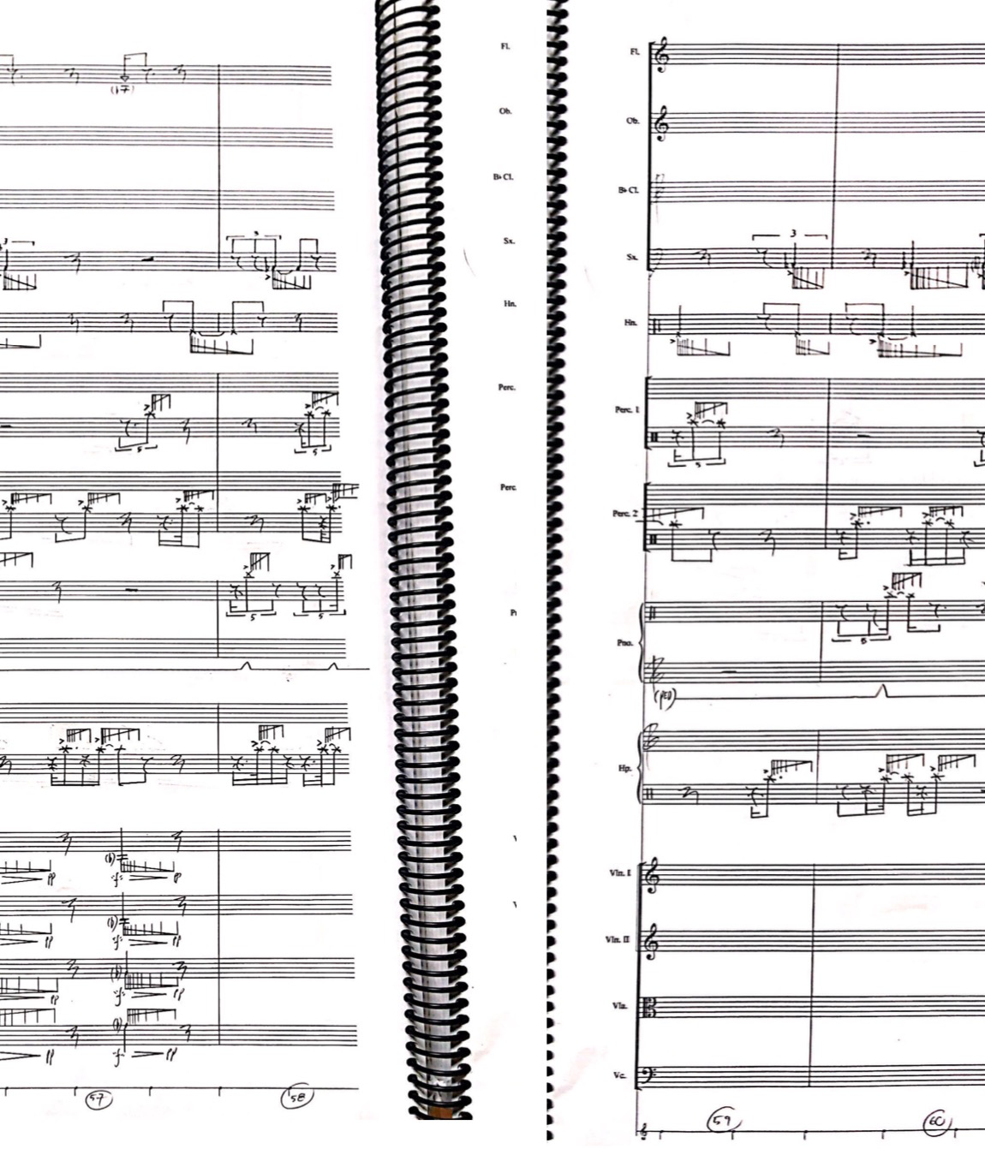

For now, I will keep m. 60 in manuscript, and skip m. 59 - for ease of proofreading, after which I will change the bar numbers to the correct version.

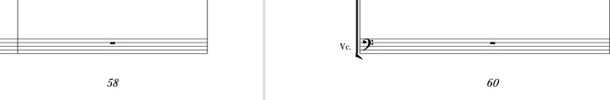

You’re right, cool, lets leave 59 out for now

The scrape/ricochet notation (seen in several bars, but especially in mm. 53-63) is a little complicated to set up. Still working on it, so currently that section won’t have that notation. I’ve started to set it up, but noticed the resolution when printed isn’t great, so I’m trying a different fix soon.

**Bar specific questions**

**All errors are marked in the score in Pink**

|  |  |  |  |
| --- | --- | --- | --- |
| Measure/Beat | Instrument | Question | Answer |
| 3 | Pno | Is the instruction for * only for the first note, whereas the instruction for ** is for all the following notes due to the simile? | No, both should apply to all stopped multiphonic cases (use only one * as you did - no need for **)  Also, my instruction is not right. Should read “Partials should get higher as the fundamentals get lower“  Your arrows are all the same height, whenever using that technique I’d like for the arrows up height to visually represent that idea, as on manuscript. |
| 8 | Perc. II | What instrument is this? | Inside piano  Perc 2 is inside piano from beginning until m.63 |
| 14 | Hn | I've added "***f***" | Thanks, lets actually make every case of horn slap just *f*, instead of *“f”* for consistency...for the entire piece |
| 51-52 | Ob | What’s the best way to present this fingering information. Do you have any scores (of your own, or others) I could reference? | I tried to write them as I want to see them, except “#14” which represents number in the book. I use Bärenreiter series for all multiphonics. In all multiphonics write exactly as in manuscript minus number inside a circle. Ab should be diamond shaped note head and empty  For this specific one you’re missing the read details and the pressure (rectangle should be something like 80% black and 20% empty.  I will attach photos of the book and even send them to you in pdfs food reference |
| M. 53 | Hn | Are these percussive notes to be transposed down in the part, or appear on same line regardless of transposition? | Same line, non-pitched…  MAybe lets write instead “Popping sound (palm smack on mouthpiece or other equivalent sounding technique)” |
| 113 | Sax | Added Bass Clef | Sorry, delete treble clefs for every key clicks on this passage, they are all C# |